# Spring Certification Module 2 - AOP

# Question 01 - What is the concept of AOP? Which problem does it solve? What is a cross cutting concern? Name three typical cross cutting concerns. What two problems arise if you don't solve a cross cutting concern via AOP?

## What is the Concept of AOP?

AOP – Aspect Oriented Programming – A programming paradigm that complements Object-oriented Programming (OOP) by providing a way to separate groups of crosscutting concerns from business logic code. This is achieved by ability to add additional behaviour to the code without having to modify the code itself. This is achieved by specifying:

*  Location of the code which behaviour should be altered – Pointcut is matched with Join point
*  Code which should be executed that implements cross cutting concern – Advice

## Question 01 - Which problem does it solve?

Aspect Oriented Programming solves the following challenges:

*  Allows proper implementation of Cross-Cutting Concerns
*  Solves Code Duplications by eliminating the need to repeat the code for functionalities across different layers, such functionalities may include logging, performance logging, monitoring, transactions, caching
*  Avoids mixing unrelated code, for example mixing transaction logic code (commit, rollback) with business code makes code harder to read, by separating concerns code is easier to read, interpret, maintain

## Question 01 – Name three typical cross cutting concerns?

Common cross-cutting concerns:

*  Logging
*  Performance Logging
*  Caching
*  Security
*  Transactions
*  Monitoring

## Question 01 - What two problems arise if you don't solve a cross cutting concern via AOP?

Implementing cross-cutting concerns without using AOP, produces following challenges:

*  Code duplications – Before/After code duplicated in all locations when normally Advise would be applied, refactoring by extraction helps but does not fully solve the problem
*  Mixing of concerns – business logic code mixed with logging, transactions, caching makes code hard read and maintain

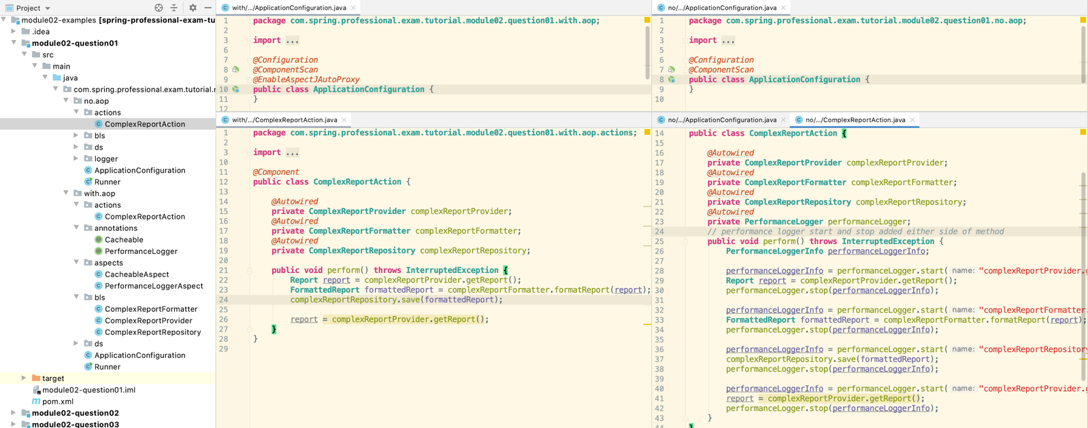

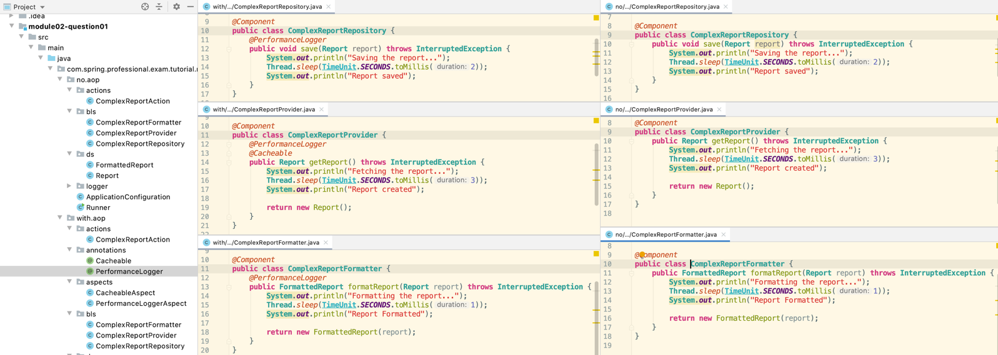

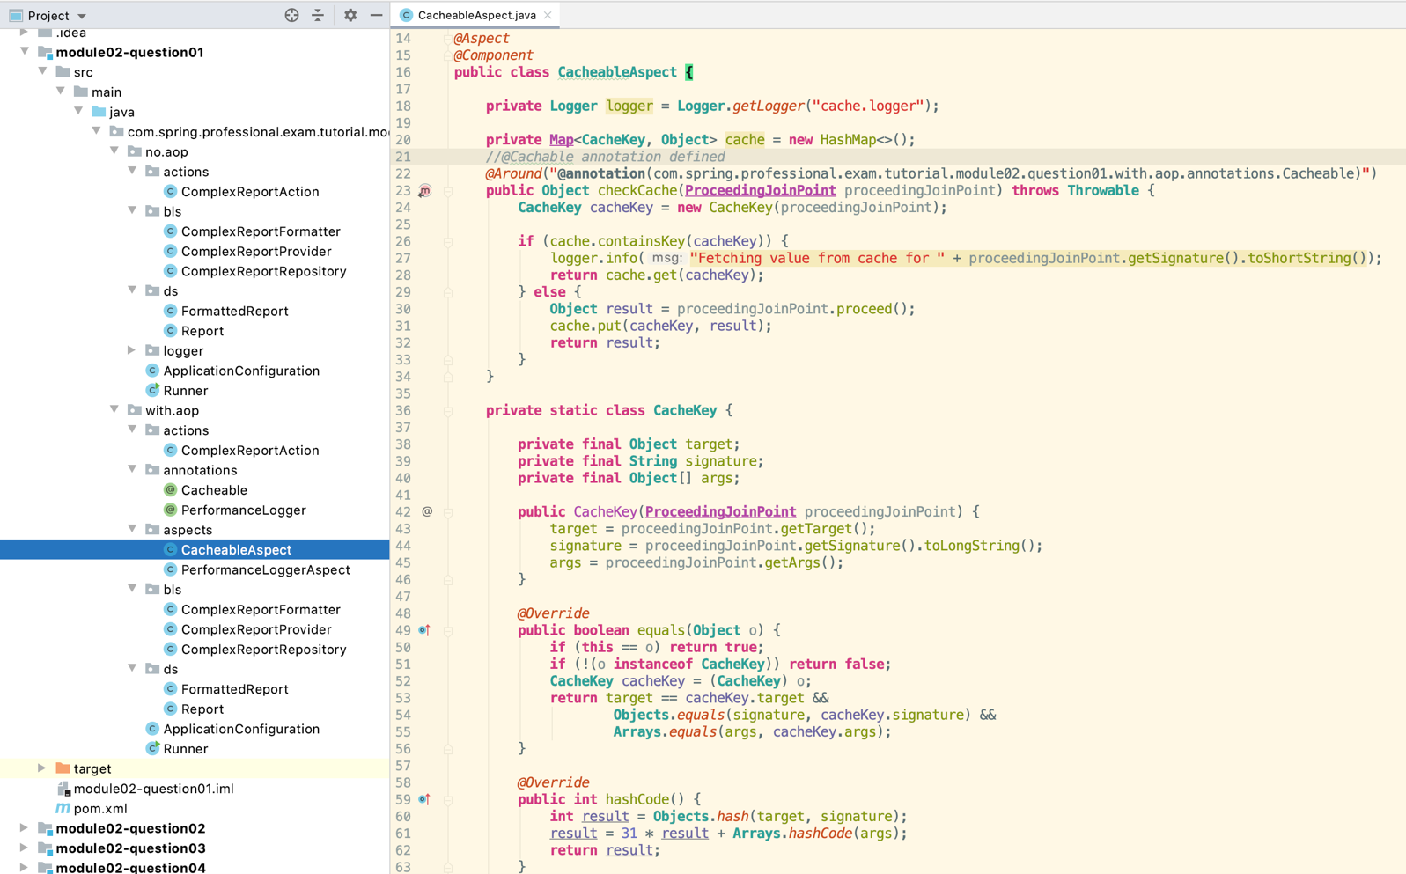

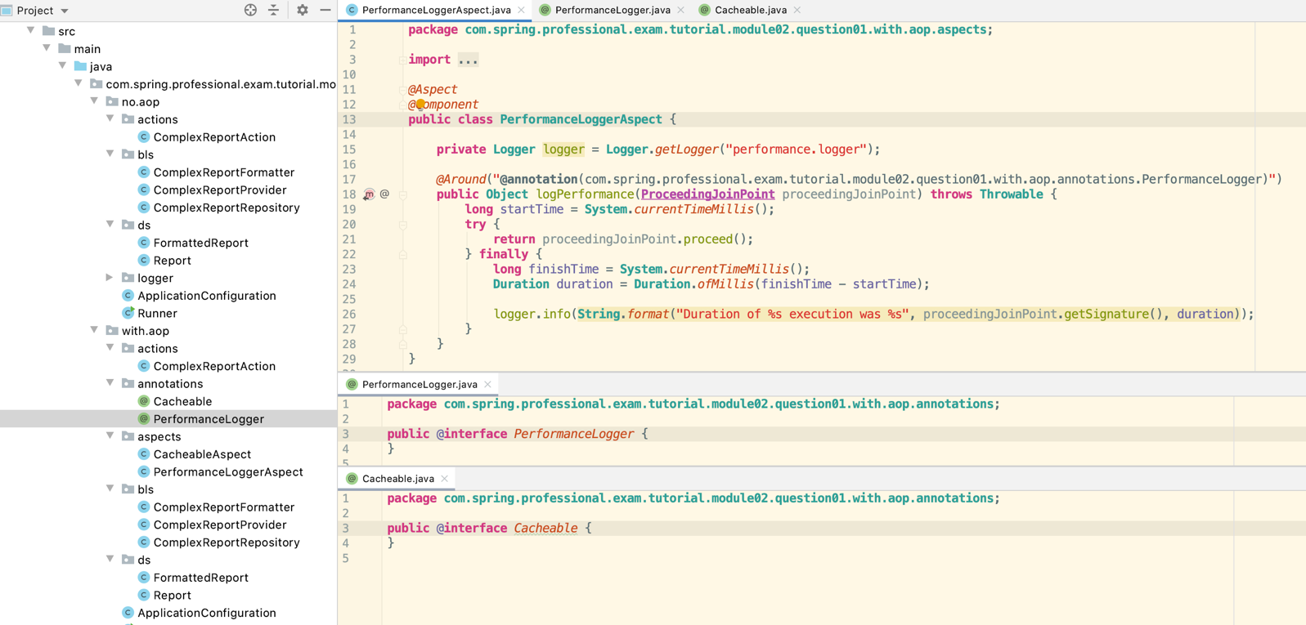

Question 02 - What is a pointcut, a joinpoint, an advice, an aspect, weaving?

Join Point in aspect oriented programming is a point in execution of a program in which behavior can be altered by AOP.

In Spring AOP Join Point is always method execution.

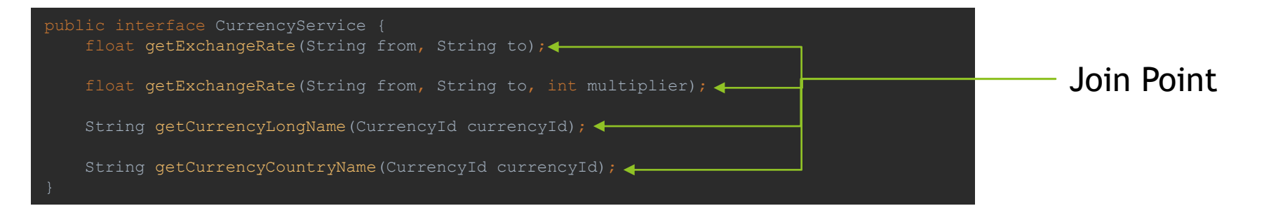

Aspect Oriented Programming concept in general, distinguishes additional Join Points, some of them include:

*  Method Execution / Invocation
*  Constructor Execution / Invocation
*  Reference / Assignment to Field
*  Exception Handler
*  Execution of Advice
*  Execution of Static Initializer / Object Initializer

## PointCut

Pointcut is a predicate used to match join point. Additional code, called Advice is executed in all parts of the program that are matching pointcut. Spring uses the AspectJ pointcut expression language by default.

Example of Pointcut Expressions:

*  execution - Match Method Execution
  + execution(* com.spring.professional.exam.tutorial.module02.question02.bls.CurrencyService.getExchangeRate(..))
*  within - Match Execution of given type or types inside package
  + within(com.spring.professional.exam.tutorial.module02.question02.bls.*)
*  @within – Match Execution of type annotated with annotation
  + @within(com.spring.professional.exam.tutorial.module02.question02.annotations.Secured)
*  @annotation – Match join points where the subject of the join point has the given annotation
  + @annotation(com.spring.professional.exam.tutorial.module02.question02.annotations.InTransaction)
*  bean – Match by spring bean name
  + bean(currency_service)
*  args – Match by method arguments
  + args(String, String, int)
*  @args – Match by runtime type of the method arguments that have annotations of the given type
  + @args(com.spring.professional.exam.tutorial.module02.question02.annotations.Validated)
*  this – Match by bean reference being an instance of the given type (for CGLIB-based proxy)
  + this(com.spring.professional.exam.tutorial.module02.question02.bls.CurrencyService)
*  target – Match by target object being an instance of the given type
  + target(com.spring.professional.exam.tutorial.module02.question02.bls.CurrencyService)
*  @target – Match by class of the executing object having an annotation of the given type
  + @target(com.spring.professional.exam.tutorial.module02.question02.annotations.Secured)

Advice is additional behaviour that will be inserted into the code, at each join point matched by pointcut.

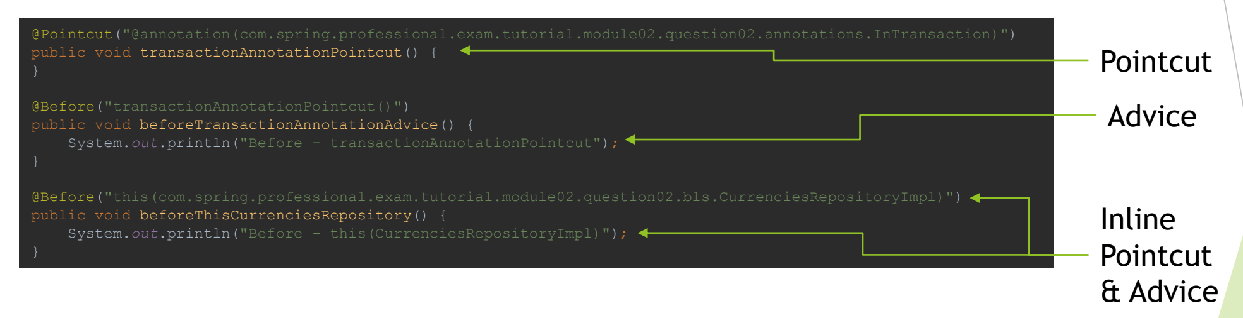

## Aspect

Aspect brings together Pointcut and Advice. Usually it represents single behaviour implemented by advice that will be added to all join points matched by pointcut.

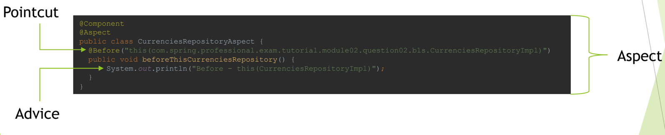

## Weaving

Weaving is the process of applying aspects, which modifies code behaviour at join points that have matching pointcuts and associated advices. During weaving aspects and application code is combined which enables execution of cross-cutting concerns.

Types of weaving:

*  Compile Time Weaving – byte code is modified during the compilation, aspects are applied, code is modified at join points matching pointcuts by applying advices
*  Load Time Weaving – byte code is modified when classes are loaded by class loaders, during class loading aspects are applied, code is modified at join points matching pointcuts by applying advices
*  Runtime Weaving – used by Spring AOP, for each object/bean subject to aspects, proxy object is created (JDK Proxy or CGLIB Proxy), proxy objects are used instead of original object, at each join point matching pointcut, method invocation is changed to apply code from advice

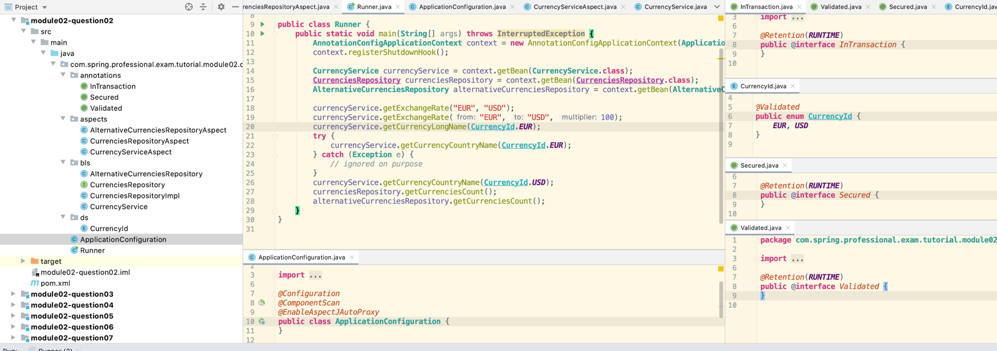

*@Component  
@Aspect***public class CurrenciesRepositoryAspect** {  
 *@Before*("this(com.spring.professional.exam.tutorial.module02.question02.bls.CurrenciesRepositoryImpl)")  
 **public void** beforeThisCurrenciesRepository() {  
 **System**.***out***.println("Before - this(CurrenciesRepositoryImpl)");  
 }  
  
 *@Before*("target(com.spring.professional.exam.tutorial.module02.question02.bls.CurrenciesRepositoryImpl)")  
 **public void** beforeTargetCurrenciesRepository() {  
 **System**.***out***.println("Before - target(CurrenciesRepositoryImpl)");  
 }  
}

*@Component  
@Aspect***public class AlternativeCurrenciesRepositoryAspect** {  
 *@Before*("this(com.spring.professional.exam.tutorial.module02.question02.bls.AlternativeCurrenciesRepository)")  
 **public void** beforeThisCurrenciesRepository() {  
 **System**.***out***.println("Before - this(AlternativeCurrenciesRepository)");  
 }  
  
 *@Before*("target(com.spring.professional.exam.tutorial.module02.question02.bls.AlternativeCurrenciesRepository)")  
 **public void** beforeTargetCurrenciesRepository() {  
 **System**.***out***.println("Before - target(AlternativeCurrenciesRepository)");  
 }  
}

*@Component  
@Aspect***public class CurrencyServiceAspect** {  
 *@Pointcut*("@annotation(com.spring.professional.exam.tutorial.module02.question02.annotations.InTransaction)")  
 **public void** transactionAnnotationPointcut() {  
 }  
  
 *@Pointcut*("within(com.spring.professional.exam.tutorial.module02.question02.bls.*)")  
 **public void** blsPackagePointcut() {  
 }  
  
 *@Pointcut*("@within(com.spring.professional.exam.tutorial.module02.question02.annotations.Secured)")  
 **public void** securedClassPointcut() {  
 }  
  
 *@Pointcut*("execution(* com.spring.professional.exam.tutorial.module02.question02.bls.CurrencyService.getExchangeRate(..))")  
 **public void** getExchangeRateMethodPointcut() {  
 }  
  
 *@Pointcut*("bean(currency_service)")  
 **public void** namedBeanPointcut() {  
 }  
  
 *@Pointcut*("args(String, String, int)")  
 **public void** stringsAndIntegerArgumentsMethodPointcut() {  
 }  
  
 *@Pointcut*("@args(com.spring.professional.exam.tutorial.module02.question02.annotations.Validated)")  
 **public void** validatedArgumentPointcut() {  
 }  
  
 *@Pointcut*("target(com.spring.professional.exam.tutorial.module02.question02.bls.CurrencyService)")  
 **public void** currencyServiceTargetPointcut() {  
 }  
  
 *@Pointcut*("@target(com.spring.professional.exam.tutorial.module02.question02.annotations.Secured)")  
 **public void** currencyServiceSecuredTargetPointcut() {  
 }  
  
 *@Pointcut*("this(com.spring.professional.exam.tutorial.module02.question02.bls.CurrencyService)")  
 **public void** currencyServiceThisPointcut() {  
 }  
  
 *@Pointcut*("blsPackagePointcut() && transactionAnnotationPointcut()")  
 **public void** blsPackageAndInTransactionPointcut() {  
 }  
  
 *//This is using the pointcut  
// @Before("transactionAnnotationPointcut()")  
// public void beforeTransactionAnnotationAdvice() {  
// System.out.println("Before - transactionAnnotationPointcut");  
// }  
  
 //This is using the annotation as before  
 @Before*("@annotation(com.spring.professional.exam.tutorial.module02.question02.annotations.InTransaction)")  
 **public void** beforeTransactionAnnotationAdvice() {  
 **System**.***out***.println("Before - transactionAnnotationPointcut - modified");  
 }  
  
  
 *@Before*("blsPackagePointcut()")  
 **public void** beforeBlsPackageAdvice() {  
 **System**.***out***.println("Before - blsPackagePointcut");  
 }  
  
 *@Before*("securedClassPointcut()")  
 **public void** beforeSecuredClassAdvice() {  
 **System**.***out***.println("Before - securedClassPointcut");  
 }  
  
 *@Around*("getExchangeRateMethodPointcut()")  
 **public Object** aroundSecuredClassAdvice(**ProceedingJoinPoint** proceedingJoinPoint) **throws Throwable** {  
 **try** {  
 **System**.***out***.println("Before - getExchangeRateMethodPointcut");  
 **return** proceedingJoinPoint.proceed();  
 } **finally** {  
 **System**.***out***.println("After - getExchangeRateMethodPointcut");  
 }  
 }  
  
 *@After*("namedBeanPointcut()")  
 **public void** afterNamedBeanAdvice() {  
 **System**.***out***.println("After - namedBeanPointcut");  
 }  
  
 *@After*("stringsAndIntegerArgumentsMethodPointcut()")  
 **public void** afterStringsAndIntegerArgumentsMethodAdvice() {  
 **System**.***out***.println("After - stringsAndIntegerArgumentsMethodPointcut");  
 }  
  
 *@After*("validatedArgumentPointcut()")  
 **public void** afterValidatedArgumentAdvice() {  
 **System**.***out***.println("After - validatedArgumentPointcut");  
 }  
  
 *@After*("currencyServiceTargetPointcut()")  
 **public void** afterCurrencyServiceTargetAdvice() {  
 **System**.***out***.println("After - currencyServiceTargetPointcut");  
 }  
  
 *@After*("currencyServiceSecuredTargetPointcut()")  
 **public void** afterCurrencyServiceSecuredTargetAdvice() {  
 **System**.***out***.println("After - currencyServiceSecuredTargetPointcut");  
 }  
  
 *@After*("currencyServiceThisPointcut()")  
 **public void** afterCurrencyServiceThisAdvice() {  
 **System**.***out***.println("After - currencyServiceThisPointcut");  
 }  
  
 *@After*("blsPackageAndInTransactionPointcut()")  
 **public void** afterBlsPackageAndInTransactionAdvice() {  
 **System**.***out***.println("After - blsPackageAndInTransactionPointcut");  
 }  
  
 *@AfterThrowing*(value = "execution(* com.spring.professional.exam.tutorial.module02.question02.bls.CurrencyService.getCurrencyCountryName(..))", throwing = "exception")  
 **public void** afterThrowingException(**Exception** exception) {  
 **System**.***out***.println("Exception was thrown from getCurrencyCountryName: " + exception.getClass().getSimpleName());  
 }  
  
 *@AfterReturning*(value = "execution(* com.spring.professional.exam.tutorial.module02.question02.bls.CurrencyService.getCurrencyCountryName(..))", returning = "value")  
 **public void** afterThrowingException(**String** value) {  
 **System**.***out***.println("Value returned from getCurrencyCountryName: " + value);  
 }  
}

Before - getExchangeRateMethodPointcut

Before - blsPackagePointcut

Before - securedClassPointcut

Before - transactionAnnotationPointcut - modified

After - getExchangeRateMethodPointcut

After - blsPackageAndInTransactionPointcut

After - currencyServiceSecuredTargetPointcut

After - currencyServiceTargetPointcut

After - currencyServiceThisPointcut

After - namedBeanPointcut

Before - getExchangeRateMethodPointcut

Before - blsPackagePointcut

Before - securedClassPointcut

After - getExchangeRateMethodPointcut

After - currencyServiceSecuredTargetPointcut

After - currencyServiceTargetPointcut

After - currencyServiceThisPointcut

After - namedBeanPointcut

After - stringsAndIntegerArgumentsMethodPointcut

Before - blsPackagePointcut

Before - securedClassPointcut

After - currencyServiceSecuredTargetPointcut

After - currencyServiceTargetPointcut

After - currencyServiceThisPointcut

After - namedBeanPointcut

After - validatedArgumentPointcut

Before - blsPackagePointcut

Before - securedClassPointcut

After - currencyServiceSecuredTargetPointcut

After - currencyServiceTargetPointcut

After - currencyServiceThisPointcut

After - namedBeanPointcut

After - validatedArgumentPointcut

Exception was thrown from getCurrencyCountryName: IllegalArgumentException

Before - blsPackagePointcut

Before - securedClassPointcut

After - currencyServiceSecuredTargetPointcut

After - currencyServiceTargetPointcut

After - currencyServiceThisPointcut

After - namedBeanPointcut

After - validatedArgumentPointcut

Value returned from getCurrencyCountryName: USA

Before - target(CurrenciesRepositoryImpl)

Before - blsPackagePointcut

Before - target(AlternativeCurrenciesRepository)

Before - this(AlternativeCurrenciesRepository)

Before – blsPackagePointcut

Question 03 - How does Spring solve (implement) a cross cutting concern?

Spring Implements cross-cutting concerns with usage of Spring AOP module. Spring AOP uses AspectJ expression syntax for Pointcut expressions, which are matched against Join Point, code is altered with logic implemented in advices. In Spring AOP Joint Point is always method invocation.

Spring AOP uses Runtime Weaving, and for each type subject to aspects, to intercepts calls, spring creates one type of proxy:

*  JDK Proxy – created for classes that implements interface
*  CGLIB Proxy – created for class that are not implementing any interface

It is possible to force Spring to use CGLIB Proxy with usage of @EnableAspectJAutoProxy(proxyTargetClass = true)

### JDK Proxy

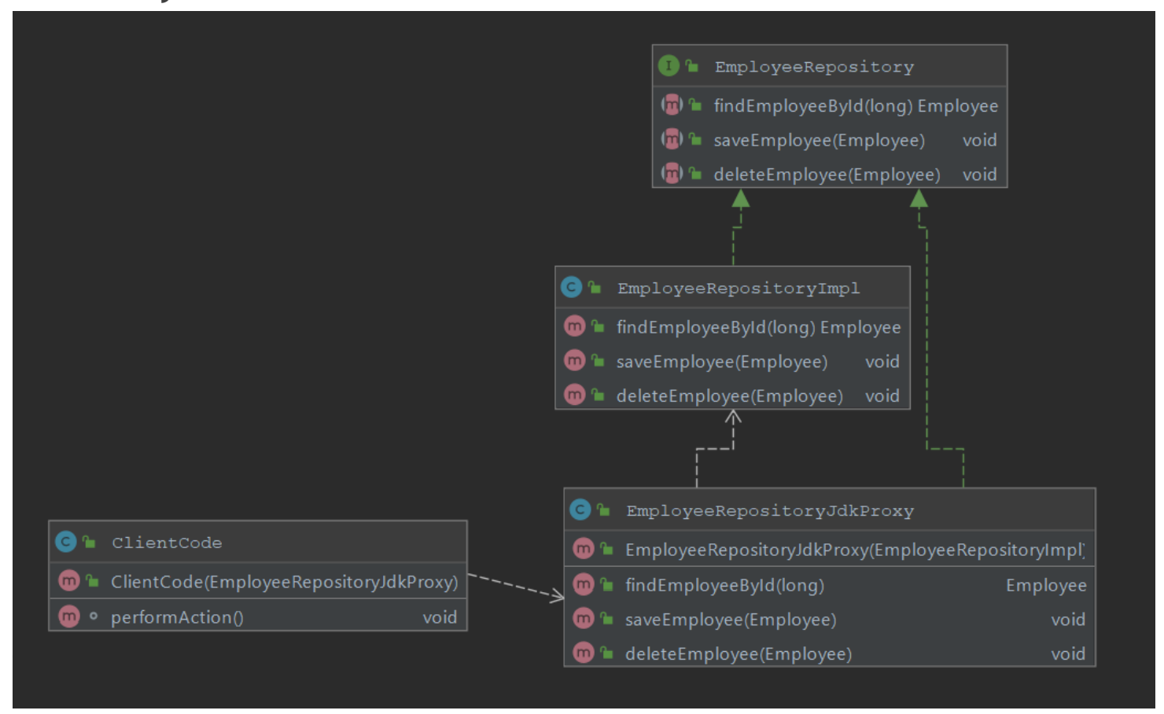

### CGLIB Proxy

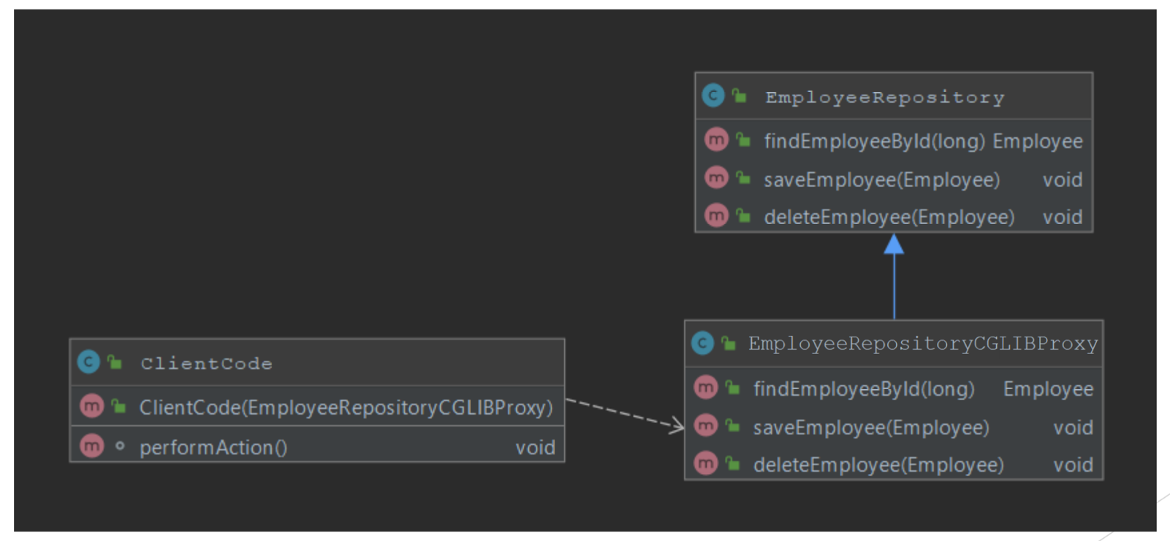

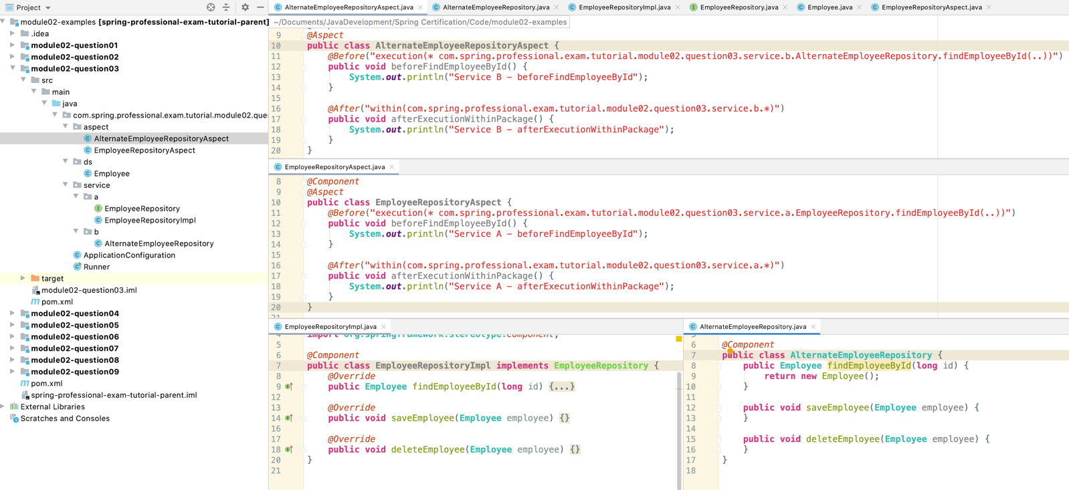

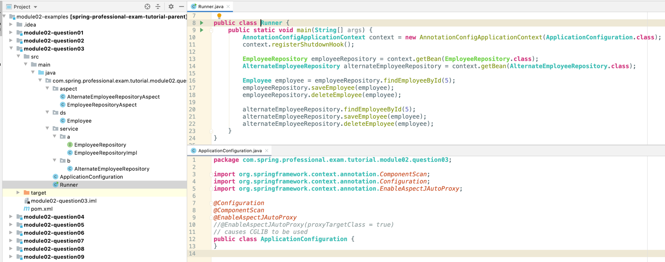

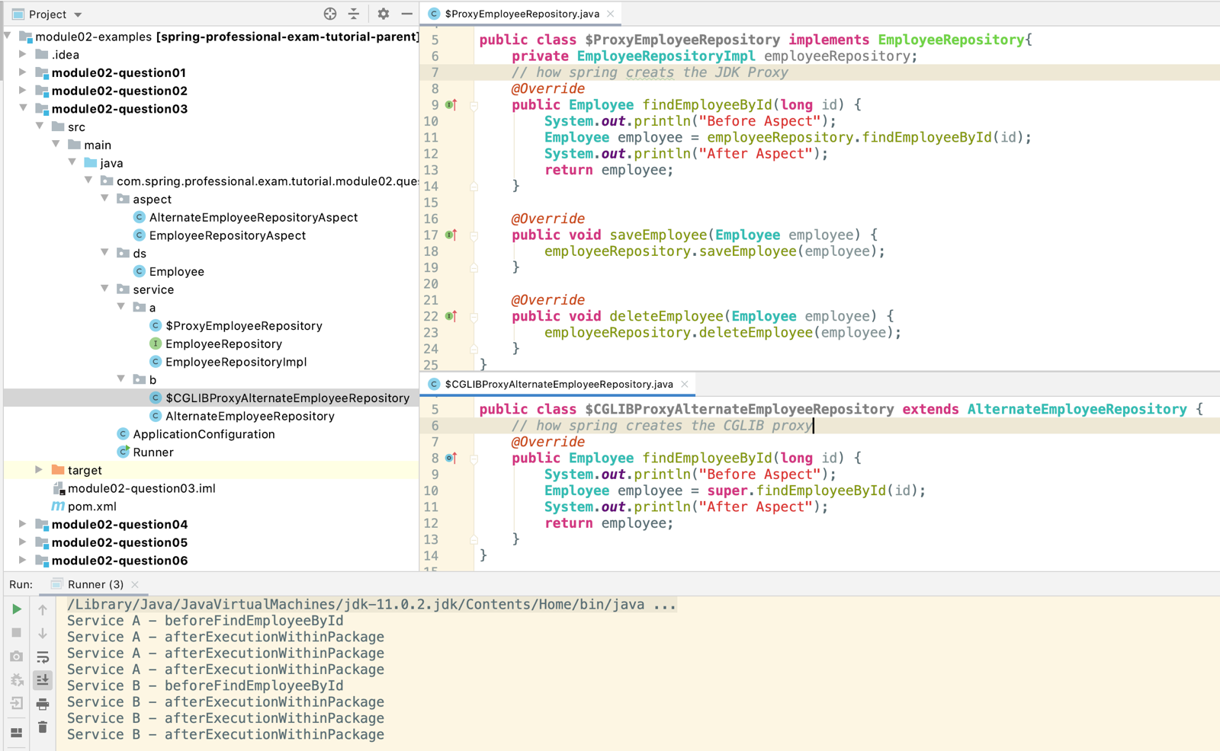

## Question 04 – What are the limitations of the two – proxy-types? What visibility must Spring bean methods have to be proxied using Spring AOP?

JDK Dynamic Proxy Limitations:

*  Does not support self-invocation
*  Class must implement interface
*  Only method implementing the interface will be proxied

CGLIB Proxy Limitations:

*  Does not support self-invocation
*  Class for which proxy should be created cannot not be final
*  Method which should be proxied cannot be final
*  Only public/protected/package methods will be proxied, private methods are not proxied

Spring Bean Method needs to have the following visibility level to be proxied:

*  JDK Dynamic Proxy – public
*  CGLIB Proxy – public/protected/package

On top of requirement above, for call to be proxied, it needs to come from outside, both JDK Dynamic Proxy and CGLIB proxy does not support self-invocation.

**public class Runner** {  
 **public static void** main(**String**[] args) **throws NoSuchMethodException**, **InvocationTargetException**, **IllegalAccessException** {  
 **AnnotationConfigApplicationContext** context = **new** AnnotationConfigApplicationContext(**ApplicationConfiguration**.**class**);  
 context.registerShutdownHook();  
  
 **EmployeeRepository** employeeRepository = context.getBean(**EmployeeRepository**.**class**);  
 **AlternateEmployeeRepository** alternateEmployeeRepository = context.getBean(**AlternateEmployeeRepository**.**class**);  
 **SamePackageEmployeeRepository** samePackageEmployeeRepository = context.getBean(**SamePackageEmployeeRepository**.**class**);  
  
*// employeeRepository.findAndUpdateEmployeeById(5, new Employee());  
// employeeRepository.findEmployeeById(5);  
// employeeRepository.saveEmployee(new Employee());  
// employeeRepository.deleteEmployee(new Employee());  
  
 // ******* try and invoke none interface method *********** //  
// ((EmployeeRepositoryImpl) employeeRepository).deleteByEmail("bob@bob.com"); Does not work because can't be proxied as not part of the interface  
 // use reflection - also fails  
// Method deleteByEmail = employeeRepository.getClass().getDeclaredMethod("deleteByEmail", String.class);  
// deleteByEmail.setAccessible(true);  
// deleteByEmail.invoke(samePackageEmployeeRepository, "john@corp.net");  
  
 //alternateEmployeeRepository.findAndUpdateEmployeeById(5, new Employee());  
 //alternateEmployeeRepository.findEmployeeById(5);  
 //alternateEmployeeRepository.saveEmployee(new Employee());  
 //alternateEmployeeRepository.deleteEmployee(new Employee());  
  
 //samePackageEmployeeRepository.saveEmployee(new Employee());  
 //samePackageEmployeeRepository.deleteEmployee(5);  
 //samePackageEmployeeRepository.deleteEmployeeByEmail("john@corp.net");* samePackageEmployeeRepository.deleteEmployeeByPhone("7049653"); *// this only works if method isn't private  
  
 // invoke the private method deleteEmployeeByPhone using reflection  
 //Method deleteEmployeeByPhone = samePackageEmployeeRepository.getClass().getSuperclass().getDeclaredMethod("deleteEmployeeByPhone", String.class);  
 //deleteEmployeeByPhone.setAccessible(true);  
 //deleteEmployeeByPhone.invoke(samePackageEmployeeRepository, "202-555-0140");* }  
}

*@Component***public final class EmployeeRepositoryImpl implements EmployeeRepository** { *// this class can be final  
 @Override* **public Employee** findEmployeeById(**long** id) {  
 **return new** Employee();  
 }  
  
 *@Override* **public void** saveEmployee(**Employee** employee) {  
 }  
  
 *@Override* **public** */*final*/* **void** deleteEmployee(**Employee** employee) {  
 }  
  
 *@Override* **public void** findAndUpdateEmployeeById(**long** id, **Employee** employeeToMerge) {  
 **Employee** employeeById = findEmployeeById(id); *// self invocation so no proxy or aspect* saveEmployee(employeeById); *// self invocation so no proxy or aspect* deleteByEmail("ted@ted.com"); *// this works but not with aspect as it is self invoked* }  
  
 **public void** deleteByEmail(**String** email) { *// this method is not part of the interface so not included in the proxy  
 // hence no aspect* }  
}

**public interface EmployeeRepository** {  
 **Employee** findEmployeeById(**long** id);  
  
 **void** saveEmployee(**Employee** employee);  
  
 **void** deleteEmployee(**Employee** employee);  
  
 **void** findAndUpdateEmployeeById(**long** id, **Employee** employeeToMerge);  
}

*@Component***public** */*final*/* **class AlternateEmployeeRepository** { *// this will fail if it is made final* **public Employee** findEmployeeById(**long** id) {  
 **return new** Employee();  
 }  
  
 **public void** saveEmployee(**Employee** employee) {  
 }  
  
 **public final void** deleteEmployee(**Employee** employee) { *// will not execute aspect if this is final but still works* **System**.***out***.println("Delete Employee is working");  
 }  
  
 **public void** findAndUpdateEmployeeById(**long** id, **Employee** employeeToMerge) {  
 **Employee** employeeById = findEmployeeById(id);  
 saveEmployee(employeeById);  
 }  
}

*@Component***public class SamePackageEmployeeRepository** {  
 **public void** saveEmployee(**Employee** employee) {  
 }  
  
 **protected void** deleteEmployee(**long** id) {  
 }  
  
 **void** deleteEmployeeByEmail(**String** email) {  
 }  
 *// aspects don't work on private methods - have to use reflection  
 /*private*/* **void** deleteEmployeeByPhone(**String** phone) {  
 **System**.***out***.println("deleteEmployeeByPhone method called");  
 }  
}

*@Configuration  
@ComponentScan  
@EnableAspectJAutoProxy***public class ApplicationConfiguration** {  
}

## Question 05 – How many advice types does Spring support. Can you name each one? What are they used for? Which two advices can you use if you would like to try and catch exceptions?

### Question 05.1 – How many advice types does Spring support. Can you name each one?

Spring supports following advice types:

*  @Before – executed before joint point matched by pointcut is executed
*  @After – executed after joint point matched by pointcut is executed
*  @AfterThrowing – executed when exception is thrown from joint point matched by pointcut
*  @AfterReturning – executed after joint point matched by pointcut is executed successfully without any exception
*  @Around – allows you to take full control over joint point matched by pointcut, most powerful advice, allows you to implement all advices from above, you need to call ProceedingJoinPoint::proceed() to execute original code

### Question 05.2– What are they used for?

Some examples of usage for each Advice type:

*  @Before
  +  Authorization, Security
  +  Logging
  +  Data Validation
*  @After
  +  Logging
  +  Resource Cleanup
*  @AfterThrowing
  +  Logging
  +  Error Handling
*  @AfterReturning
  +  Logging
  +  Data Validation for method result
*  @Around
  +  Transactions
  +  Distributed Call Tracing
  +  Authorization, Security

### Question 05.3– Which two advices can you use if you would like to try and catch exceptions?

To catch exceptions you can use two advices:

*  @AfterThrowing with throwing field set and exception passed as argument
*  @Around with try … catch block implemented

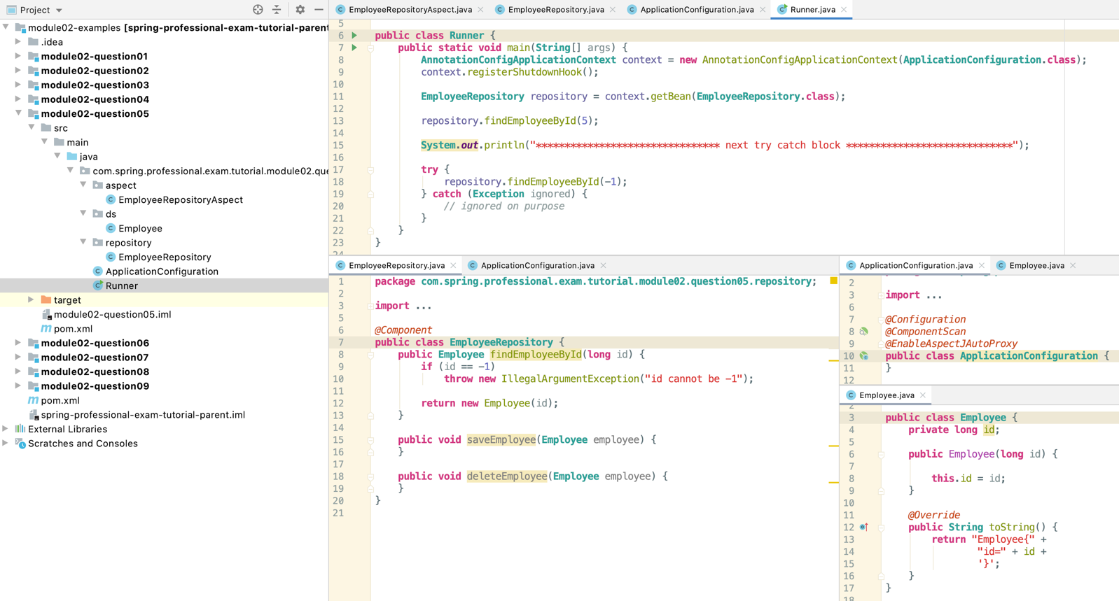

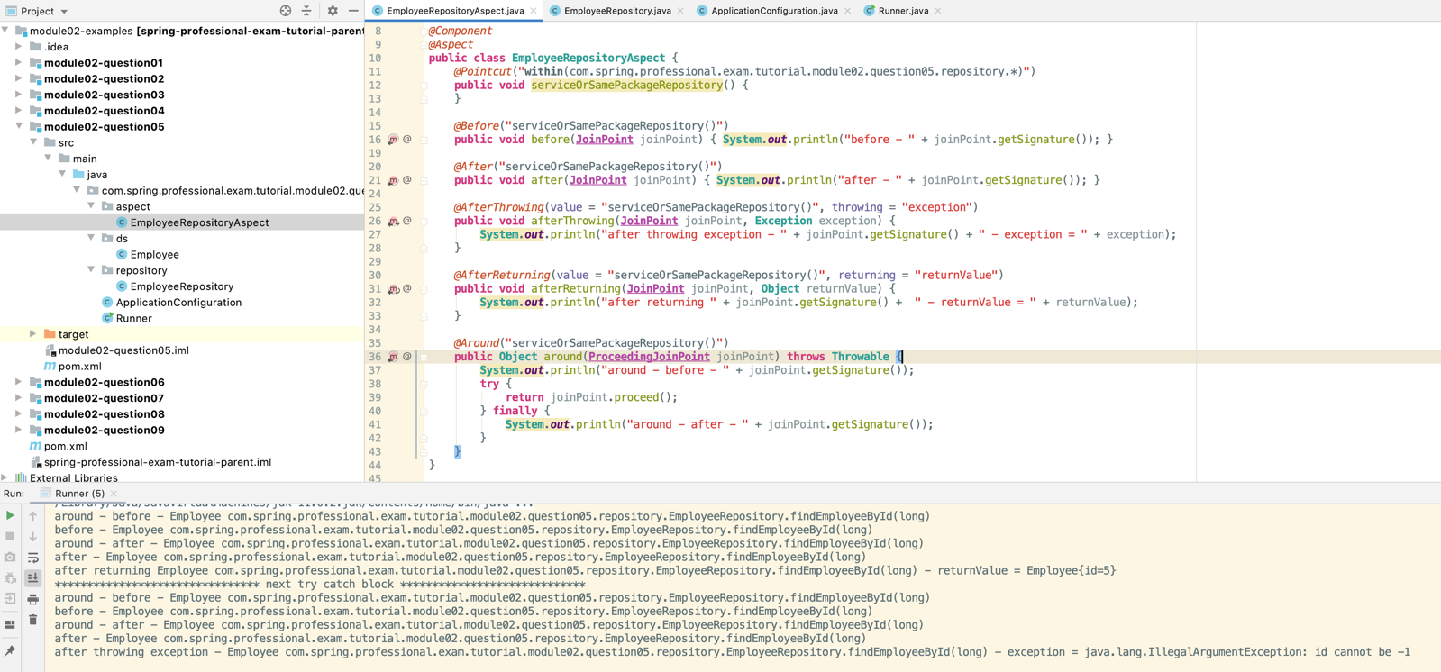

## Question 06 – What do you have to do to enable the detection of the @Aspect annotation? What does @EnableAspectJAutoProxy do?

To enable detection of @Aspect annotation you need to:

*  Have @Configuration class with @EnableAspectJAutoProxy
  +  Without @EnableAspectJAutoProxy Spring will not scan for @Aspect
*  Have beans for @Aspect annotated classes created
  +  Use @ComponentScan with @Component at class annotated with @Aspect
  +  Use @Bean in Configuration class and create Spring Aspect Bean manually
*  Have aspectjweaver/spring-aop on classpath
  +  It is easiest to use org.springframework:spring-aspects dependency to have those included
  +  Without required dependencies on classpath spring will fail with ClassNotFoundException/NoClassDefFoundError during creation of Proxy objects for Spring Beans subject to aspects

Annotation @EnableAspectJAutoProxy enables detection of @Aspect classes and creates proxy object for beans subject to aspects. Internally process of creating proxies is done by AnnotationAwareAspectJAutoProxyCreator. By creating a proxy for each bean subject to aspects, spring intercepts the calls and implements Before / After / AfterReturning / AfterThrowing / Around advices. It is important to remember that @Aspect will not create Spring Beans on it’s own, you need to use Component Scanning or manually create beans for @Aspect classes.

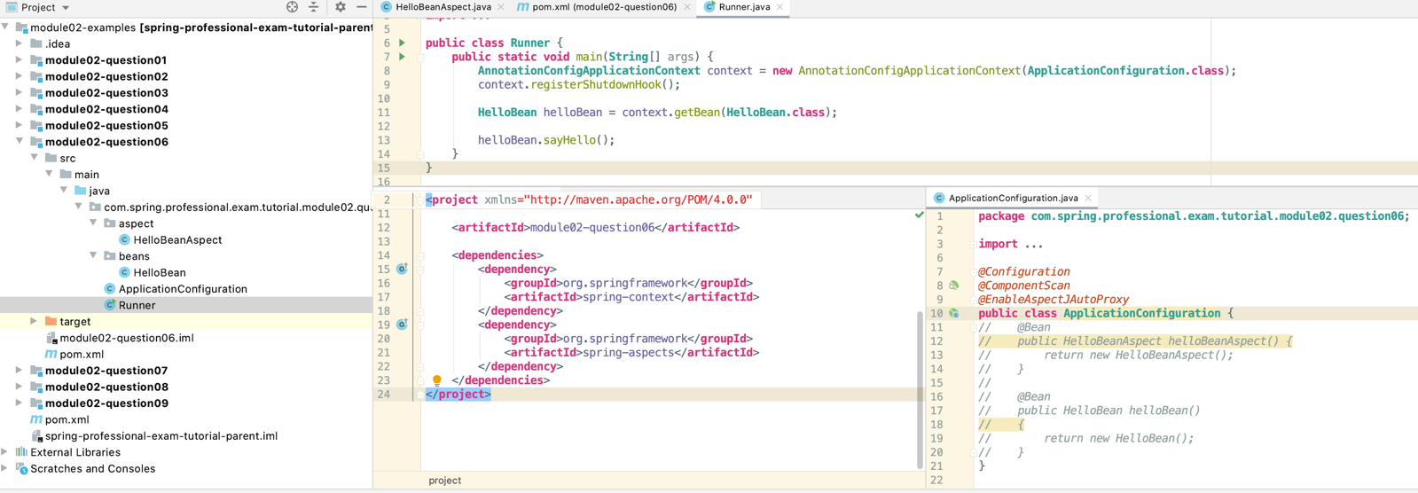

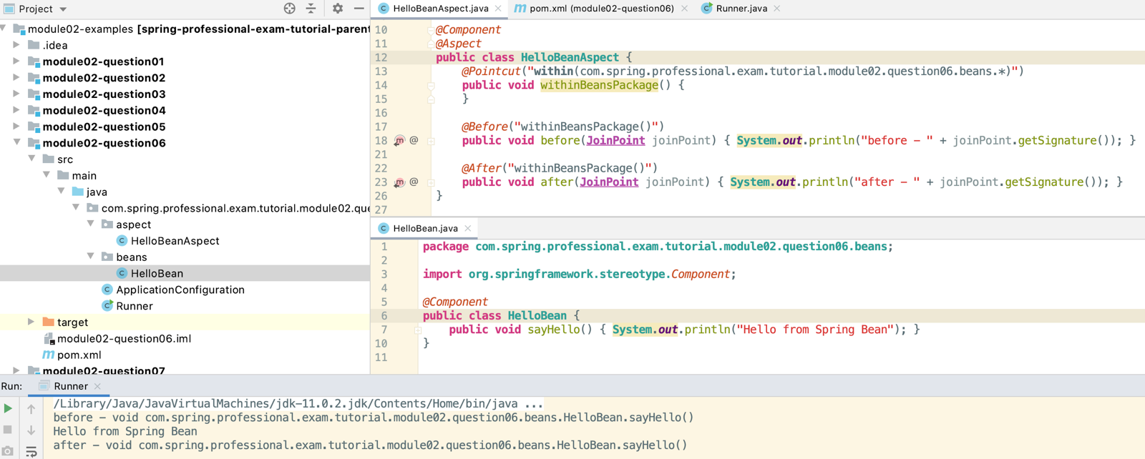

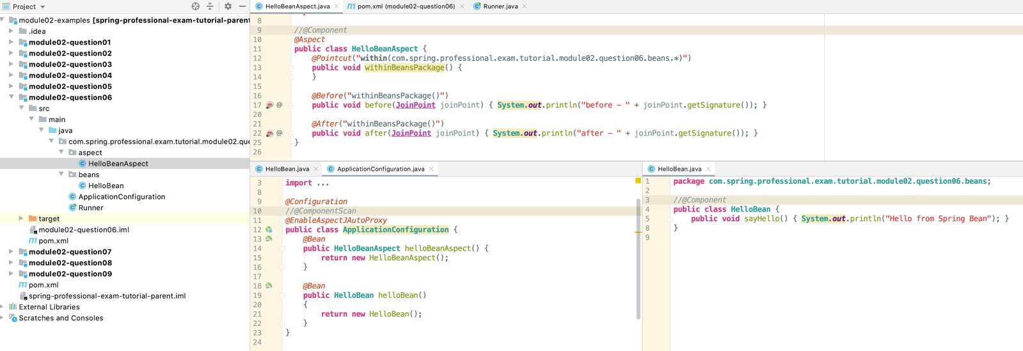

## Question 07 – If shown pointcut expressions, would you understand them? For example, what would be the correct pointcut expression to match both getter and setter methods?

Pointcut designator types supported by Spring AOP:

*  execution
*  within
*  args
*  bean
*  this
*  target
*  @annotation
*  @args
*  @within
*  @target

### 07.01 Pointcut designator – execution – matches method execution

General Form: execution([visibility modifiers] [return type] [package].[class].[method]([arguments]) [throws exceptions]

Description:

*  [visibility modifiers] – public/protected, if omitted all are matched, can be used with negation, for example !protected
*  [return type] – void, primitive or Object type, cannot be omitted, can be used with wildcard *, can be used with negation, for example !int
*  [package] – package in which class is located, may be omitted if class is located within same package as aspect, wildcard * may be used to match all packages, wildcard .. may be used to match all sub-packages
*  [class] – Class name to match against, may be omitted, may be used with * wildcard, matches subclasses of the
* class as well
*  [method] – Name of the method, whole or partial method name can be used with * wildcard
*  [arguments] – May be empty to match methods without any arguments, may be used with wildcard .. to match zero or more arguments, may be used with wildcard * to match all types of specific argument, may be used with ! Negation
*  [throws exceptions] – Match method that throws exceptions from given list, can be used with negation !

*@Component  
@Aspect***public class HelloBeanAspect** {  
 *@Before*("execution(public !int com..HelloBean.say*(String, *))") //Matches HelloBean and HelloChildBean sayHello(String n, int x)  
 **public void** executionExample() {  
 **System**.***out***.println("Before - execution example");  
 }  
  
 *@After*("execution(void com..HelloChildBean.validateName(..) throws java.io.IOException)") //Matches HelloChildBean validateName(String x)  
 **public void** executionWithExceptionExample() {  
 **System**.***out***.println("After - execution with exception matcher example");  
 }

### 07.02 Pointcut designator – within – matches execution within specified class/classes, optionally you can specify class package

General Form: within([package].[class])

Description:

*  [package] – package where class is located, may be used with .. wildcard (includes all sub-packages) or with * wildcard, may be omitted
*  [class] – class against which match should happen, may be used with * wildcard

*@Before*("within(com..HelloChildBean)")   
**public void** withinExample1() {  
 **System**.***out***.println("Before - withinExample1");  
}  
  
*@Before*("within(com..*)")  
**public void** withinExample2() {  
 **System**.***out***.println("Before - withinExample2");  
}  
  
*@Before*("within(com..Hello*Bean)")  
**public void** withinExample3() {  
 **System**.***out***.println("Before - withinExample3");  
}

### 07.03 Pointcut designator – args – matches execution of method with matching arguments

General Form: args([parameter_type1, parameter_type2, ..., parameter_typeN])

Description:

*  [parameter_typeN] – simple or object type, may be * to indicate one parameter of any type, may be .. to indicate zero or more arguments, you can specify type with the package

*@Before*("args(..)")  
**public void** argsExample1() {  
 **System**.***out***.println("Before - argsExample1");  
}  
  
*@Before*("args(String, int)")  
**public void** argsExample2() {  
 **System**.***out***.println("Before - argsExample2");  
}  
  
*@Before*("args(String, *)")  
**public void** argsExample3() {  
 **System**.***out***.println("Before - argsExample3");  
}  
  
*@Before*("args(java.lang.String)")  
**public void** argsExample4() {  
 **System**.***out***.println("Before - argsExample4");  
}

### 07.04 Pointcut designator – bean – matches execution of method with matching Spring Bean Name

General Form: bean([beanName])

Description:

*  [beanName] – name of the Spring Bean (automatically generated by framework, or set manually).

*@Before*("bean(hello_child_bean)") // this is from *@Component*("hello_child_bean")  
**public void** beanExample1() {  
 **System**.***out***.println("Before - beanExample1");  
}  
  
*@Before*("bean(hello_*_bean)")  
**public void** beanExample2() {  
 **System**.***out***.println("Before - beanExample2");  
}

### 07.05 Pointcut designator – this – matches execution against type of proxy that was generated by Spring AOP

General Form: this([type])

Description:

*  [type] – type of the proxy, matches if generated proxy is of specified type

### 07.06 Pointcut designator – target – matches execution against type of the target object invoked by proxy

General Form: target([type])

Description:

*  [type] – type of the target object invoked by proxy, matches if target object is of specified type

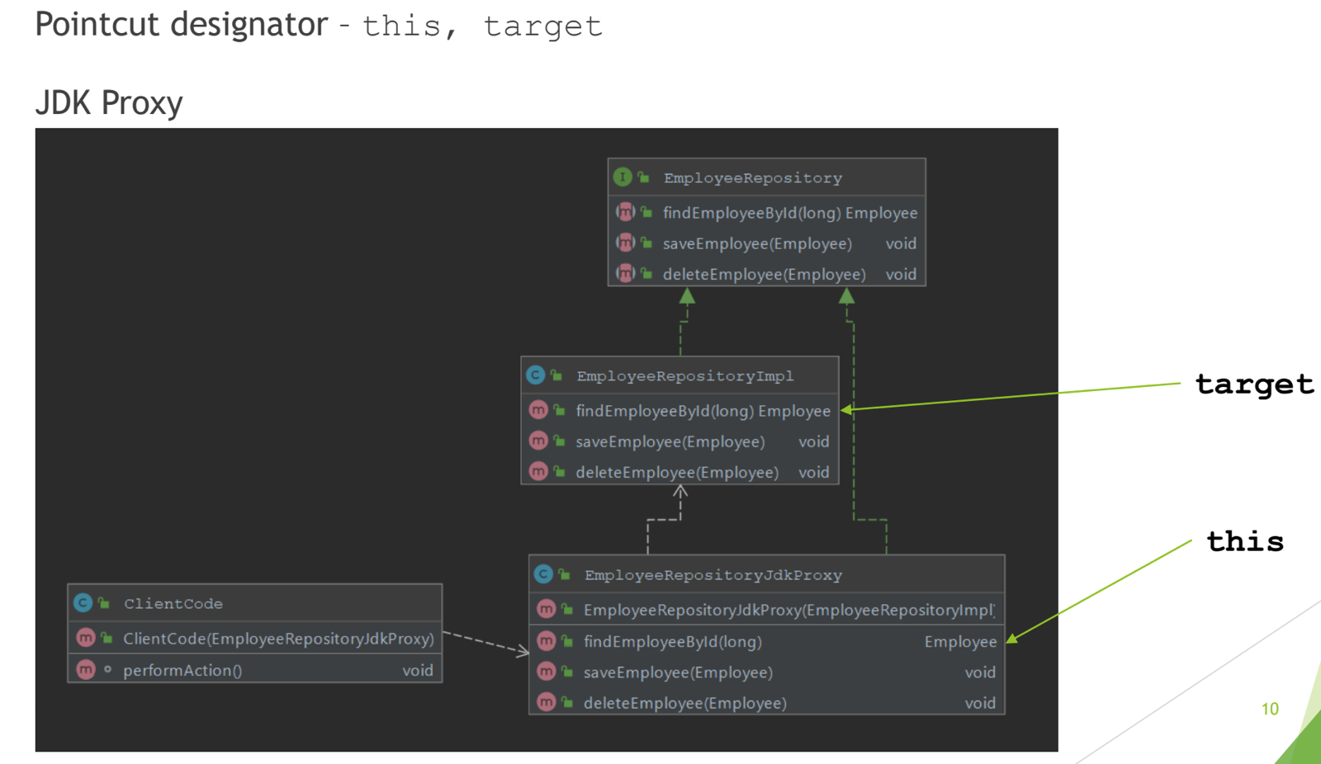

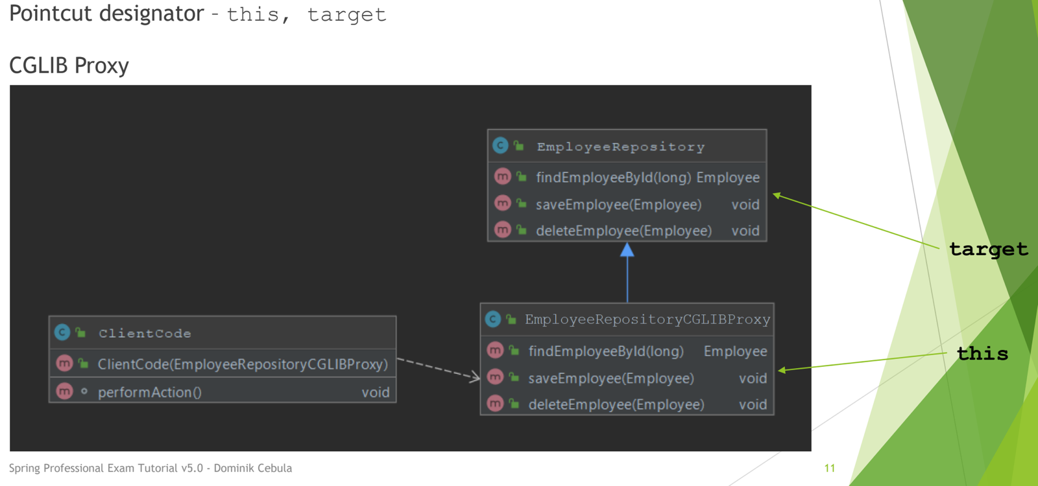

*@Component  
@Aspect***public class TaxBeanAspect** {  
 *@Before*("this(com.spring.professional.exam.tutorial.module02.question07.beans.ITaxBean)")  
 **public void** thisTaxBean1Example1() {  
 **System**.***out***.println("Before - thisTaxBean1Example1");  
 }  
  
 *@Before*("this(com.spring.professional.exam.tutorial.module02.question07.beans.TaxBean1)")  
 **public void** thisTaxBean1Example2() {  
 **System**.***out***.println("Before - thisTaxBean1Example2");  
 }  
  
 *@Before*("target(com.spring.professional.exam.tutorial.module02.question07.beans.ITaxBean)")  
 **public void** targetTaxBean1Example1() {  
 **System**.***out***.println("Before - targetTaxBean1Example1");  
 }  
  
 *@Before*("target(com.spring.professional.exam.tutorial.module02.question07.beans.TaxBean1)")  
 **public void** targetTaxBean1Example2() {  
 **System**.***out***.println("Before - targetTaxBean1Example2");  
 }  
  
 *@Before*("this(com.spring.professional.exam.tutorial.module02.question07.beans.TaxBean2)")  
 **public void** thisTaxBean2Example() {  
 **System**.***out***.println("Before - thisTaxBean2Example");  
 }  
  
 *@Before*("target(com.spring.professional.exam.tutorial.module02.question07.beans.TaxBean2)")  
 **public void** targetTaxBean2Example() {  
 **System**.***out***.println("Before - targetTaxBean2Example");  
 }  
}

### 07.07 Pointcut designator – @annotation – matches method execution annotated with specified annotation

General Form: @annotation([annotation_type])

Description:

*  [annotation_type] – type of annotation used to annotated method which should match pointcut expression

*@Before*("@annotation(com.spring.professional.exam.tutorial.module02.question07.annotation.CustomTransaction)")  
**public void** annotationExample() {  
 **System**.***out***.println("Before - annotationExample");  
}

**public** @**interface** *CustomTransaction* {  
}

*@Component*("hello_child_bean")  
**public class HelloChildBean extends HelloBean** {  
 *@CustomTransaction* **public void** saveCounterValue(**int** counterValue) {  
 }

### 07.08 Pointcut designator – @args – matches method execution with argument, which types

(classes) are annotated with specified annotation type, note that class should be annotated, not the argument of method itself

General Form: @args([annotation_type])

Description:

*  [annotation_type] – type of annotation used on top of class, which represents type of argument

*@Before*("@args(com.spring.professional.exam.tutorial.module02.question07.annotation.CustomValidation)")  
**public void** argsAnnotationExample()  
{  
 **System**.***out***.println("Before - @argsExample");  
}

*@CustomValidation***public class Person** { // this is the argument of the savePerson()  
}

*@Component*("hello_child_bean")  
**public class HelloChildBean extends HelloBean** {  
   
 **public void** savePerson(**Person** person) { //useds Person which is annotated as the argument  
 }  
}

### 07.09 Pointcut designator – @within – matches method executions inside classes annotated with specified annotation

General Form: @within([annotation_type])

Description:

*  [annotation_type] – type of annotation used on top of class, inside which method execution should be matched

*@Component  
@Aspect***public class DepartmentRepositoryAspect** {  
 *@Before*("@within(com.spring.professional.exam.tutorial.module02.question07.annotation.MonitoredRepository)")  
 **public void** annotationWithinExample() {  
 **System**.***out***.println("Before - annotationWithinExample");  
 }

*@Retention*(**RetentionPolicy**.***RUNTIME***)  
**public** @**interface** *MonitoredRepository* {  
}

*@Component  
@MonitoredRepository // All methods in this class will be annotated***public class DepartmentRepository** {  
  
 **public Department** findDepartment(**String** pattern) {  
 **return new** Department();  
 }  
  
 **public void** updateDepartment(**int** id, **Department** department) {  
 }  
}

### 07.10 Pointcut designator – @target – matches method executions inside proxied target class that is annotated with specific annotation

General Form: @target([annotation_type])

Description:

*  [annotation_type] – type of annotation used on top of proxied class, inside which method execution should be matched

*@Component  
@Aspect***public class DepartmentRepositoryAspect** {  
 *@Before*("@within(com.spring.professional.exam.tutorial.module02.question07.annotation.MonitoredRepository)")  
 **public void** annotationWithinExample() {  
 **System**.***out***.println("Before - annotationWithinExample");  
 }  
// @target is basically the same as @Within except that it targets the proxy  
 *@Before*("@target(com.spring.professional.exam.tutorial.module02.question07.annotation.MonitoredRepository)")  
 **public void** annotationTargetExample() {  
 **System**.***out***.println("Before - annotationTargetExample");  
 }  
}

### 07.11 Pointcut expressions can be combined together with usages of logical operators:

*  ! – negation
*  || - logical or
*  && - logical and

To match getters and setter, execution Pointcut Expression can be used together with ability to combine them with logical operators.

Expression that will match getters and setter can look like this:

execution(* com.beans.EmployeeBean.get*()) || execution(* com.beans.EmployeeBean.set*(*))

*@Component  
@Aspect***public class EmployeeBeanAspect** {  
 *@Before*("execution(* com.spring.professional.exam.tutorial.module02.question07.beans.EmployeeBean.get*()) || execution(* com.spring.professional.exam.tutorial.module02.question07.beans.EmployeeBean.set*(*))")  
 **public void** beforeGetterOrSetter(**JoinPoint** joinPoint) {  
 **System**.***out***.println("beforeGetterOrSetter " + joinPoint.getSignature());  
 }  
}

*@Component***public class EmployeeBean** {  
 **private int** id;  
 **private String** name;  
 **private String** workPhone;  
 **private String** cubicId;  
  
 **public int** getId() {  
 **return** id;  
 }  
  
 **public void** setId(**int** id) {  
 **this**.id = id;  
 }

## Question 08 – What is the JoinPoint argument used for?

JoinPoint argument is an object that can be used to retrieve additional information about join point during execution. JoinPoint needs to be the first parameter of Advice, only in that case Spring Framework will inject JoinPoint into advice method.

Join Point is supported in following advice types:

*  Before
*  After
*  After Returning
*  After Throwing

Examples of information that you can retrieve from JoinPoint:

*  String representation of Join Point
*  Arguments of Joint Point (for example Method Arguments)
*  Signature of Joint Point (for example Method Signature)
*  Kind / Type of Joint Point
*  Target / This object being proxied

*@Component  
@Aspect***public class HelloBeanAspect** {  
  
 *@Before*("execution(* com..HelloBean.formatData(..))")  
 **public void** beforeHelloBean(**JoinPoint** joinPoint) {  
 **System**.***out***.println("HelloBeanAspect::beforeHelloBean <- start");  
  
 **System**.***out***.println("Join Point = " + joinPoint.getStaticPart().toLongString());  
 **System**.***out***.println("Signature = " + joinPoint.getSignature());  
 **System**.***out***.println("Args = " + **Arrays**.*toString*(joinPoint.getArgs()));  
 **System**.***out***.println("Kind = " + joinPoint.getKind());  
  
 **System**.***out***.println("HelloBeanAspect::beforeHelloBean <- stop\n\n");  
 }  
  
 *@After*("execution(* com..HelloBean.formatData(..))")  
 **public void** afterHelloBean(**JoinPoint** joinPoint) {  
 **System**.***out***.println("\n\nHelloBeanAspect::afterHelloBean <- start");  
  
 **System**.***out***.println("Join Point = " + joinPoint.getStaticPart().toLongString());  
 **System**.***out***.println("Signature = " + joinPoint.getSignature());  
 **System**.***out***.println("Args = " + **Arrays**.*toString*(joinPoint.getArgs()));  
 **System**.***out***.println("Kind = " + joinPoint.getKind());  
  
 **System**.***out***.println("HelloBeanAspect::afterHelloBean <- stop\n\n");  
 }  
  
 *@AfterReturning*(value = "execution(* com..HelloBean.formatData(..))", returning = "returnValue")  
 **public void** afterReturningHelloBean(**JoinPoint** joinPoint, **Object** returnValue) {  
 **System**.***out***.println("\n\nHelloBeanAspect::afterReturningHelloBean <- start");  
  
 **System**.***out***.println("Join Point = " + joinPoint.getStaticPart().toLongString());  
 **System**.***out***.println("Signature = " + joinPoint.getSignature());  
 **System**.***out***.println("Args = " + **Arrays**.*toString*(joinPoint.getArgs()));  
 **System**.***out***.println("Kind = " + joinPoint.getKind());  
 **System**.***out***.println("Return Value = " + returnValue);  
  
 **System**.***out***.println("HelloBeanAspect::afterReturningHelloBean <- stop\n\n");  
 }  
  
 *@AfterThrowing*(value = "within(com..HelloBean)", throwing = "exception")  
 **public void** afterThrowingHelloBean(**JoinPoint** joinPoint, **Exception** exception) {  
 **System**.***out***.println("\n\nHelloBeanAspect::afterThrowingHelloBean <- start");  
  
 **System**.***out***.println("Join Point = " + joinPoint.getStaticPart().toLongString());  
 **System**.***out***.println("Signature = " + joinPoint.getSignature());  
 **System**.***out***.println("Args = " + **Arrays**.*toString*(joinPoint.getArgs()));  
 **System**.***out***.println("Kind = " + joinPoint.getKind());  
 **System**.***out***.println("Exception = " + exception);  
  
 **System**.***out***.println("HelloBeanAspect::afterThrowingHelloBean <- stop\n\n");  
 }  
}

*@Component***public class HelloBean** {  
 **public String** formatData(**String** firstName, **String** lastName) {  
 **return String**.*format*("%s %s", firstName, lastName);  
 }  
  
 **public void** saveData(**String** name) {  
 **Objects**.*requireNonNull*(name, "Name cannot be null");  
 }  
}

**public class Runner** {  
 **public static void** main(**String**[] args) {  
 **AnnotationConfigApplicationContext** context = **new** AnnotationConfigApplicationContext(**ApplicationConfiguration**.**class**);  
 context.registerShutdownHook();  
  
 **HelloBean** helloBean = context.getBean(**HelloBean**.**class**);  
  
 helloBean.formatData("John", "Doe");  
 **try** {  
 helloBean.saveData(**null**);  
 } **catch** (**Exception** ignored) {  
 *// ignored on purpose* }  
 }  
}

HelloBeanAspect::beforeHelloBean <- start

Join Point = execution(public java.lang.String com.spring.professional.exam.tutorial.module02.question08.beans.HelloBean.formatData(java.lang.String,java.lang.String))

Signature = String com.spring.professional.exam.tutorial.module02.question08.beans.HelloBean.formatData(String,String)

Args = [John, Doe]

Kind = method-execution

HelloBeanAspect::beforeHelloBean <- stop

HelloBeanAspect::afterHelloBean <- start

Join Point = execution(public java.lang.String com.spring.professional.exam.tutorial.module02.question08.beans.HelloBean.formatData(java.lang.String,java.lang.String))

Signature = String com.spring.professional.exam.tutorial.module02.question08.beans.HelloBean.formatData(String,String)

Args = [John, Doe]

Kind = method-execution

HelloBeanAspect::afterHelloBean <- stop

HelloBeanAspect::afterReturningHelloBean <- start

Join Point = execution(public java.lang.String com.spring.professional.exam.tutorial.module02.question08.beans.HelloBean.formatData(java.lang.String,java.lang.String))

Signature = String com.spring.professional.exam.tutorial.module02.question08.beans.HelloBean.formatData(String,String)

Args = [John, Doe]

Kind = method-execution

Return Value = John Doe

HelloBeanAspect::afterReturningHelloBean <- stop

HelloBeanAspect::afterThrowingHelloBean <- start

Join Point = execution(public void com.spring.professional.exam.tutorial.module02.question08.beans.HelloBean.saveData(java.lang.String))

Signature = void com.spring.professional.exam.tutorial.module02.question08.beans.HelloBean.saveData(String)

Args = [null]

Kind = method-execution

Exception = java.lang.NullPointerException: Name cannot be null

HelloBeanAspect::afterThrowingHelloBean <- stop

## Question 09 – What is a ProceedingJoinPoint? When is it used?

ProceedingJoinPoint is an object that can be provided to @Around advice as first argument, it is a type of JoinPoint which can be used to change method arguments during method execution in runtime or block execution of original method entirely.

Proceeding JoinPoint is used in @Around advice, it contains all methods from JoinPoint and also adds:

*  proceed – executes original method
*  proceed(args) – executes original method with provided arguments

Proceeding JoinPoint can be used in following use cases:

*  Conditionally block method execution
*  Filter arguments
*  Inject additional argument

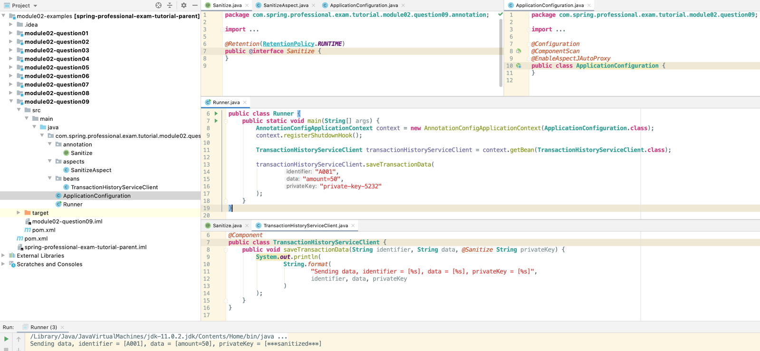

*@Component  
@Aspect***public class SanitizeAspect** {  
 *@Around*("execution(* com..beans.*.*(*, ..))")  
 **public Object** around(**ProceedingJoinPoint** proceedingJoinPoint) **throws Throwable** {  
 **MethodSignature** methodSignature = (**MethodSignature**) proceedingJoinPoint.getSignature();  
  
 **return** proceedingJoinPoint.proceed(  
 sanitizeArgumentsIfRequired(  
 proceedingJoinPoint.getArgs(),  
 methodSignature  
 )  
 );  
 }  
  
 **private Object**[] sanitizeArgumentsIfRequired(**Object**[] args, **MethodSignature** methodSignature) {  
 **Object**[] filteredArgs = **new** Object[args.length];  
 **for** (**int** i = 0; i < args.length; i++) {  
 filteredArgs[i] = sanitizeArgumentIfRequired(args[i], methodSignature.getMethod().getParameterAnnotations()[i]);  
 }  
 **return** filteredArgs;  
 }  
  
 **private Object** sanitizeArgumentIfRequired(**Object** arg, **Annotation**[] parameterAnnotations) {  
 **if** (containsAnnotationOfType(parameterAnnotations, *Sanitize*.**class**) && arg.getClass() == **String**.**class**)  
 **return** "***sanitized***";  
 **else  
 return** arg;  
 }  
  
 **private boolean** containsAnnotationOfType(**Annotation**[] parameterAnnotations, **Class** sanitizeClass) {  
 **return Arrays**.*stream*(parameterAnnotations)  
 .map(**Annotation**::annotationType)  
 .anyMatch(sanitizeClass::equals);  
 }  
}